

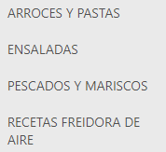





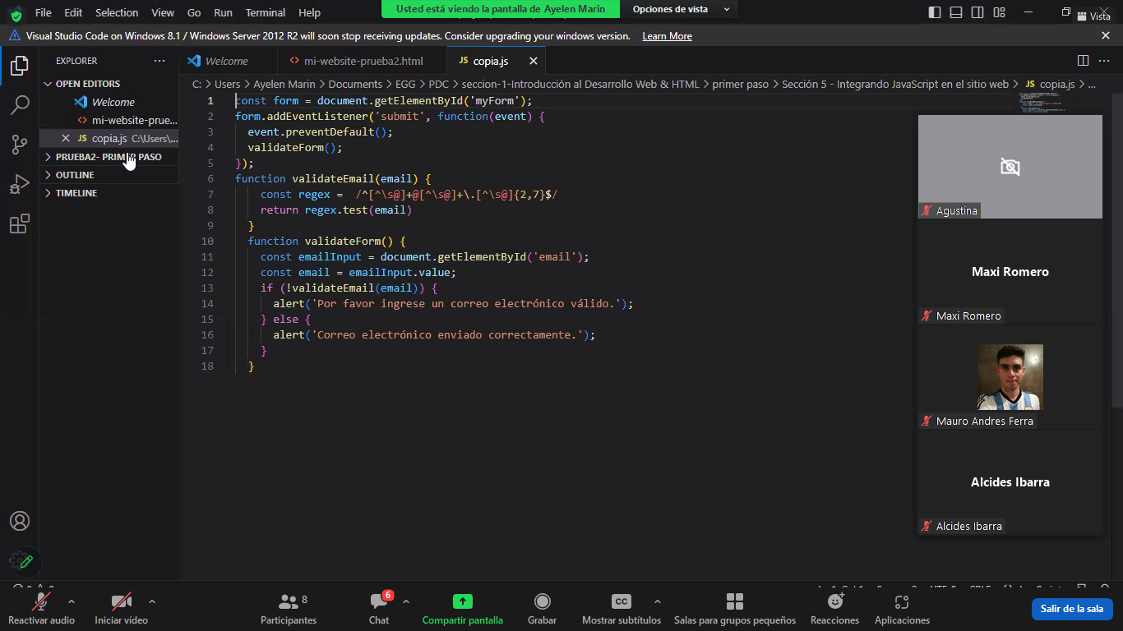

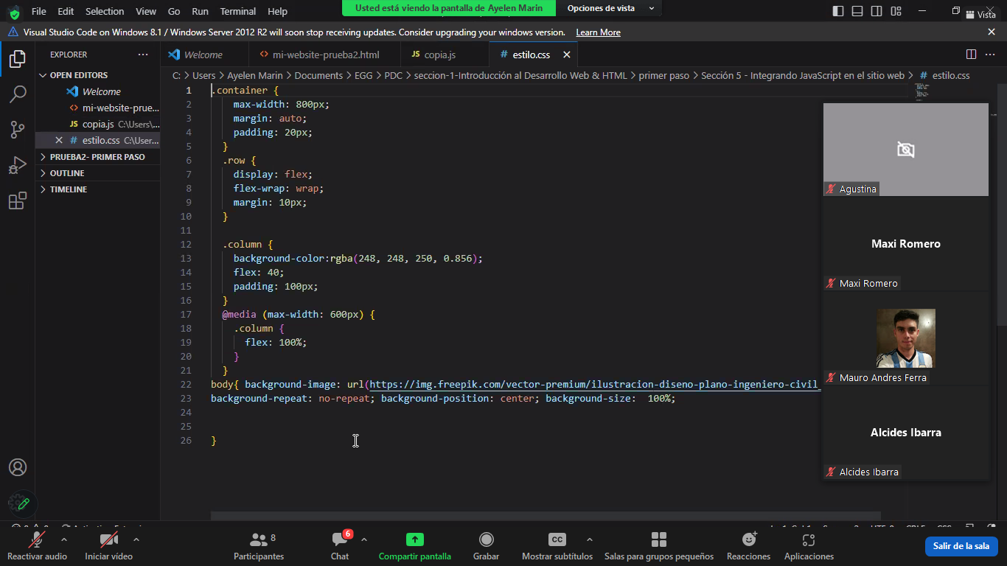

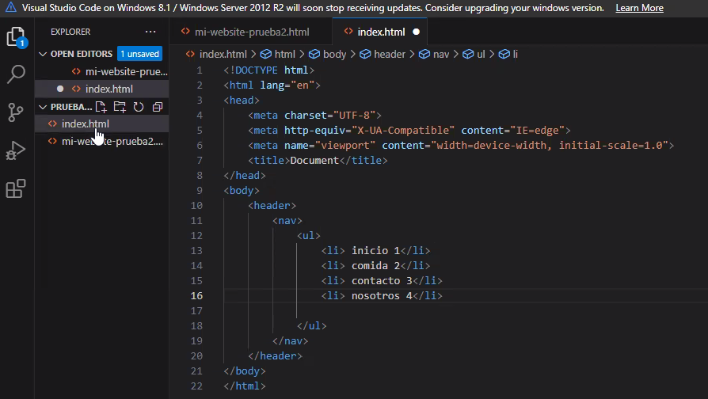

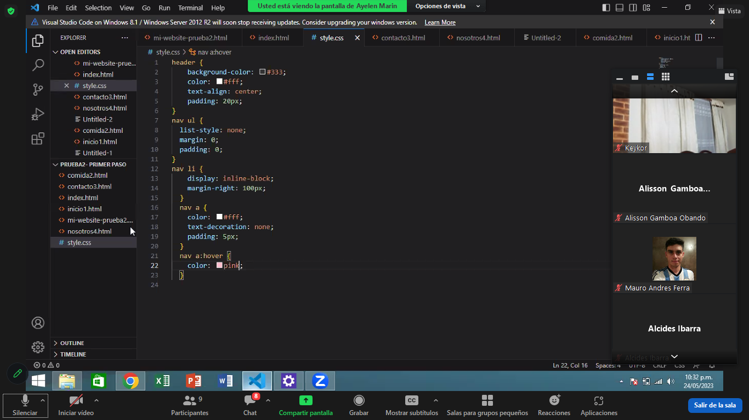

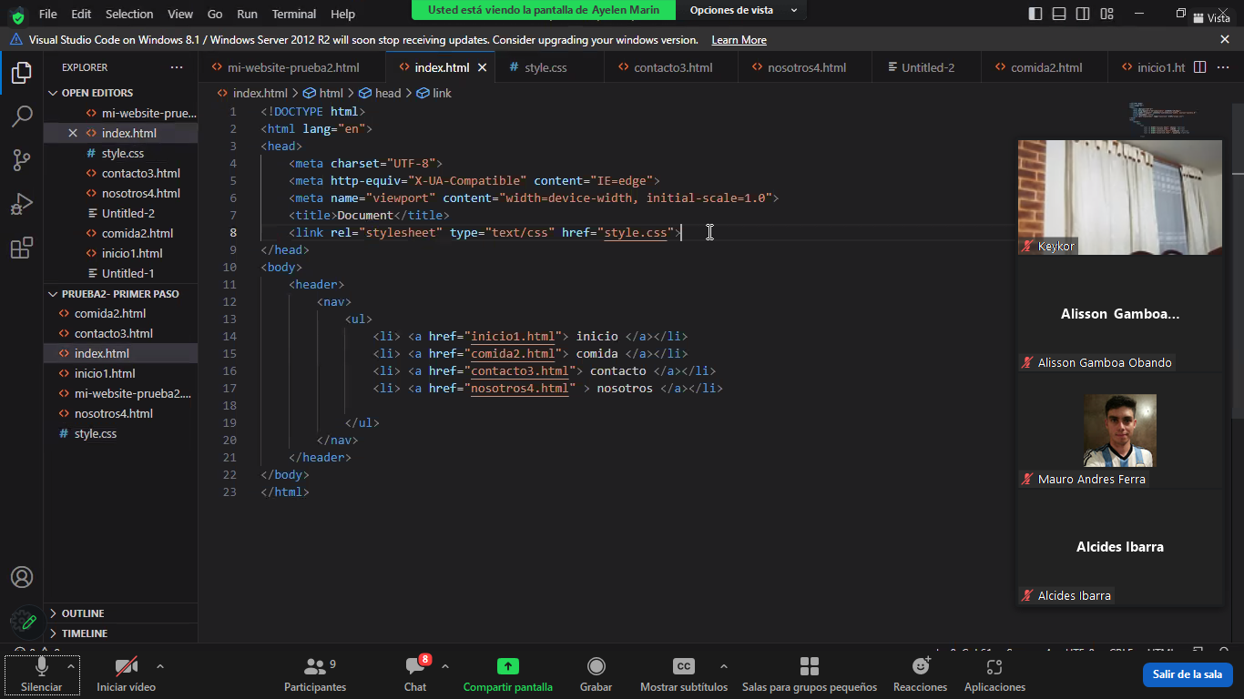

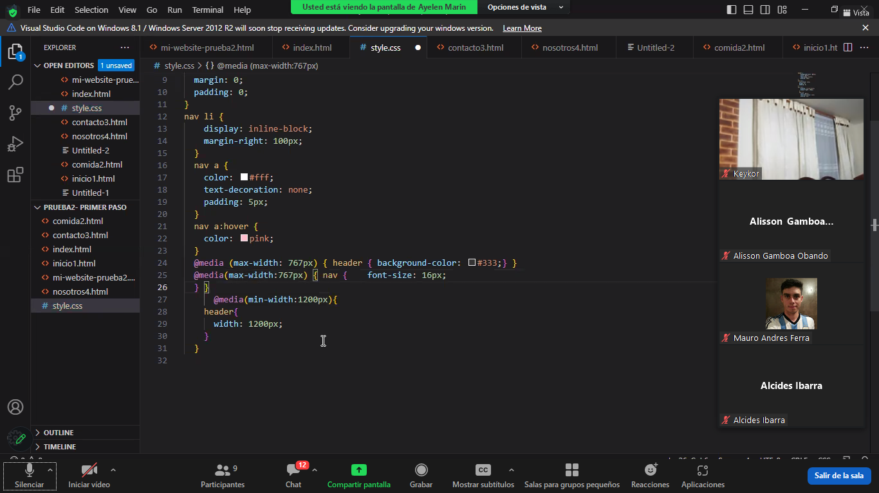

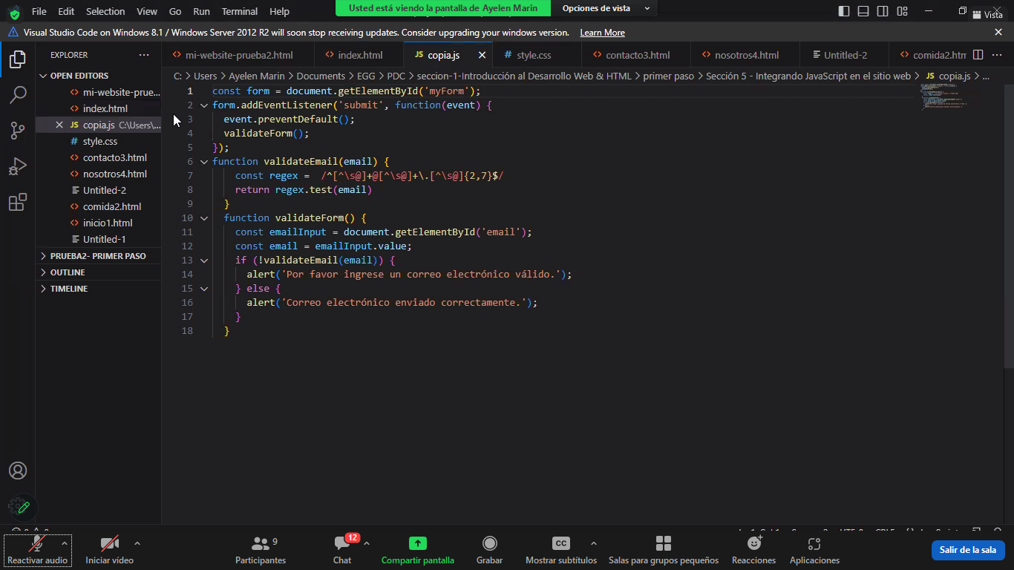

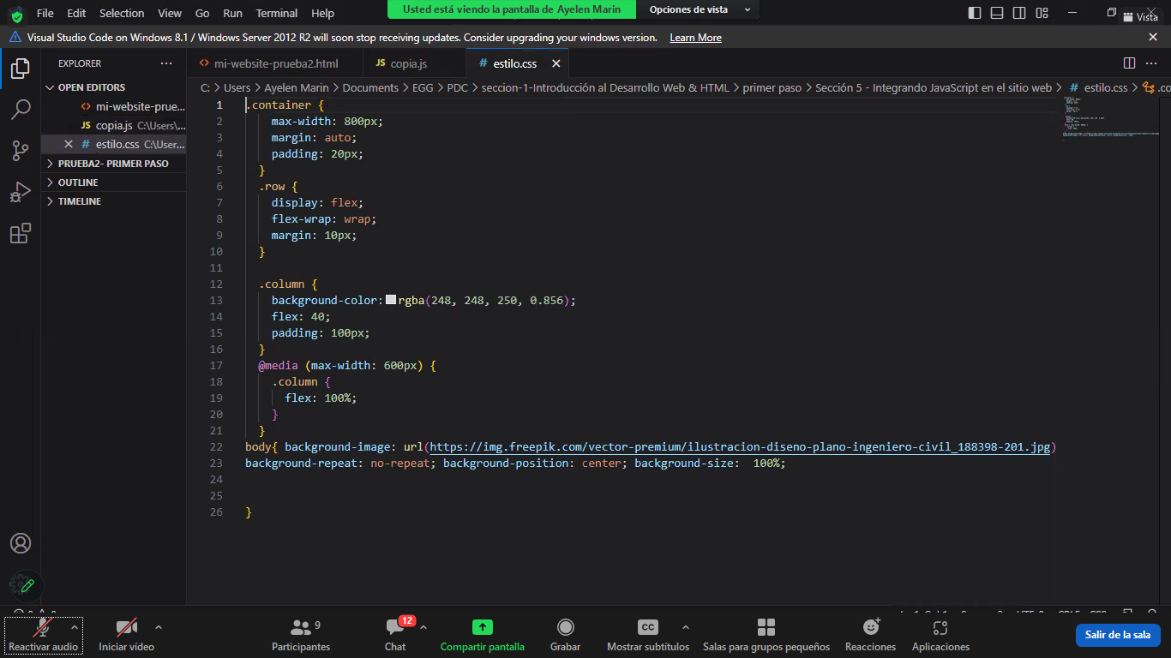

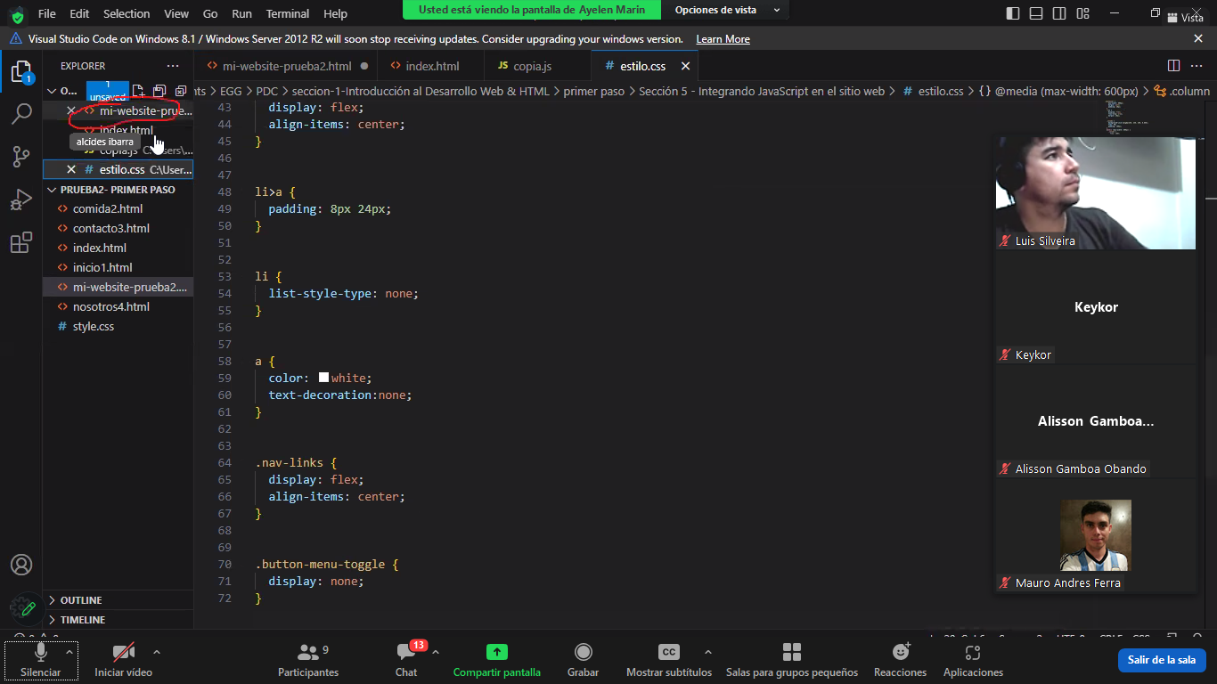

<body> <div class="original"> <div class="divexterno"> caja1 </div> <div class="divmedio"> caja2 </div> <div class="divinterno"> caja3 </div> </div></body>

0000000000000000000000000000000

.original{ display: flex; flex-direction: column; justify-content: space-between; border:solid black; background-color: brown; width: 400px; height: 400px; text-align: center;align-items: center ;}.divmedio{ width: 100%; height: 50px; border: darkkhaki; background-color: coral; } .divexterno{ width: 50px; height: 50px; border: darkkhaki; background-color: cornflowerblue; } .divinterno{ width: 50px; height: 50px; border: darkkhaki; background-color: aquamarine; }

.original{ display: flex; flex-direction: column; justify-content: space-between; border:solid black; background-color: brown; width: 400px; height: 400px; }.divmedio{ align-self: center; width: 50px; height: 50px; border: darkkhaki; background-color: coral; } .divexterno{ width: 50px; height: 50px; border: darkkhaki; background-color: cornflowerblue; } .divinterno{ align-self:flex-end; width: 50px; height: 50px; border: darkkhaki; background-color: aquamarine; }

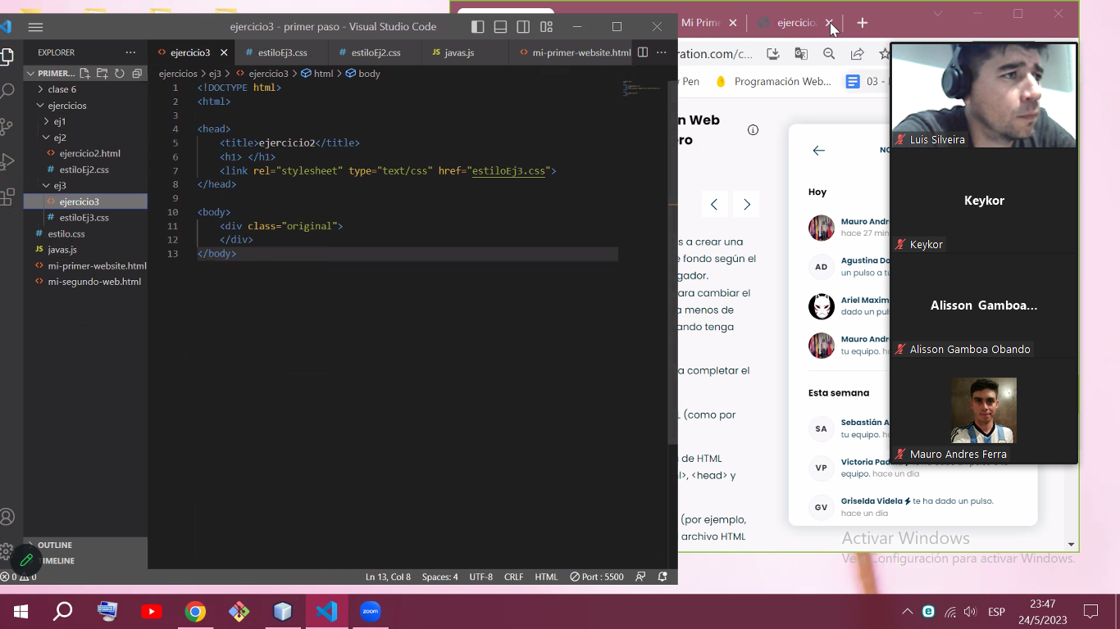

**DESAFIO DEL DIA DE LA CLASE 7**

**Mmmmmmmmmmmmmmmmmmmm**

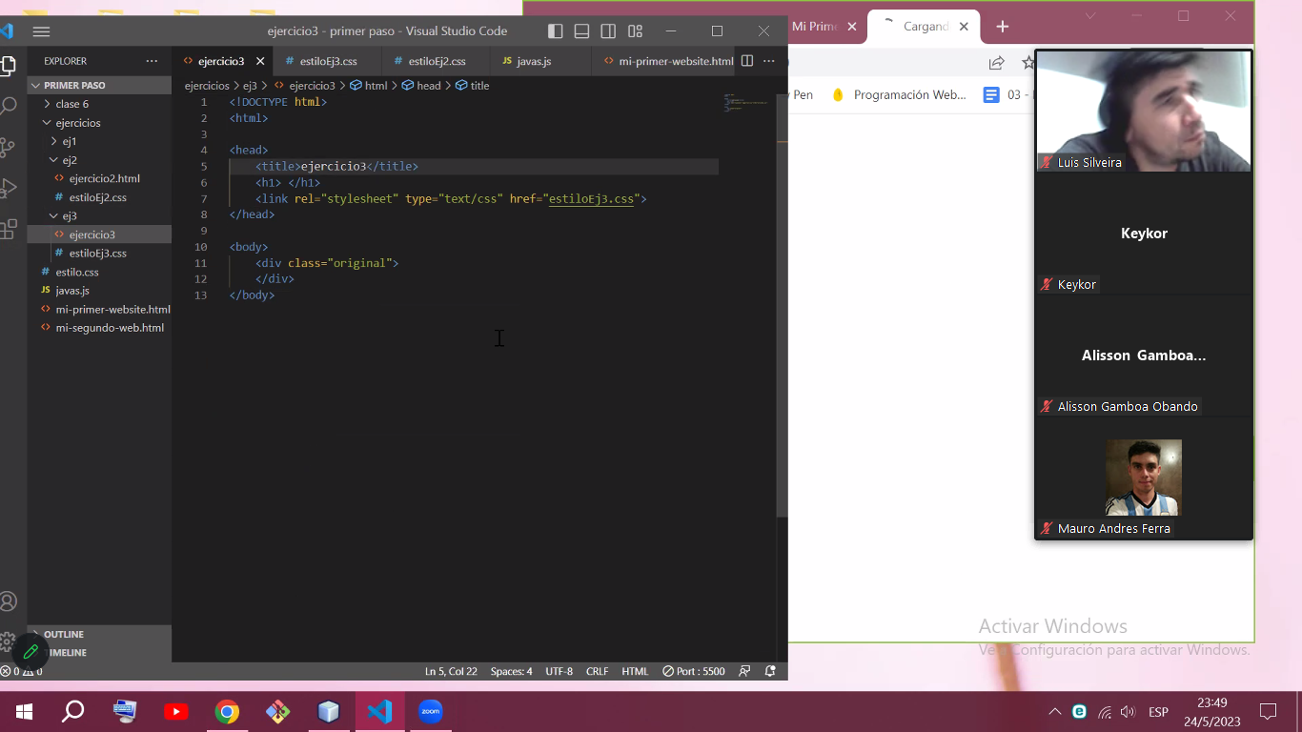

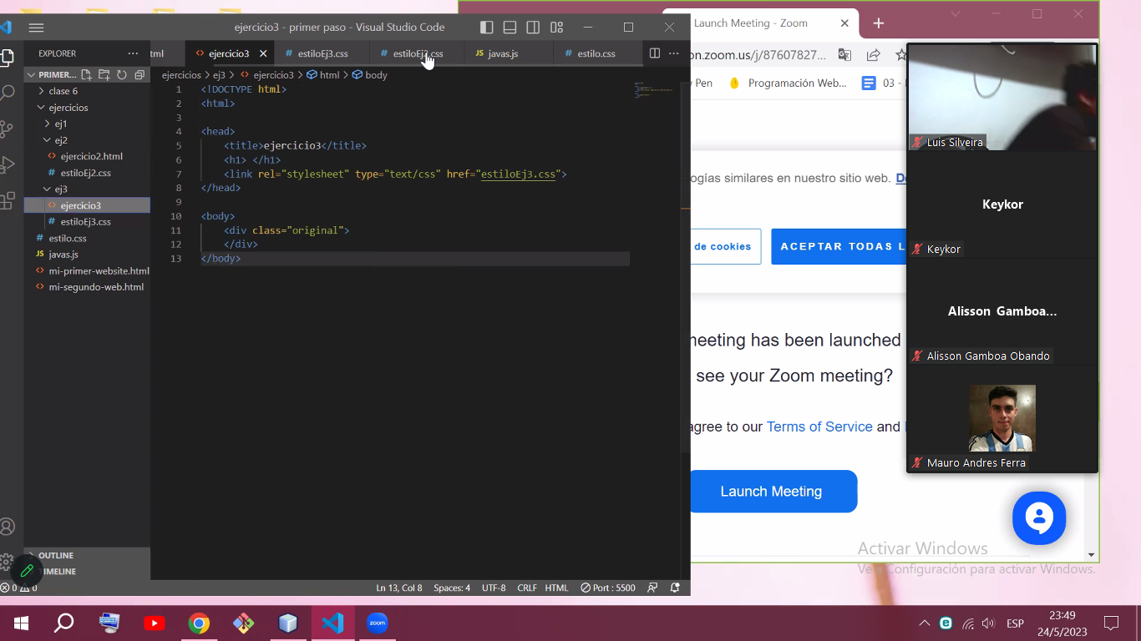

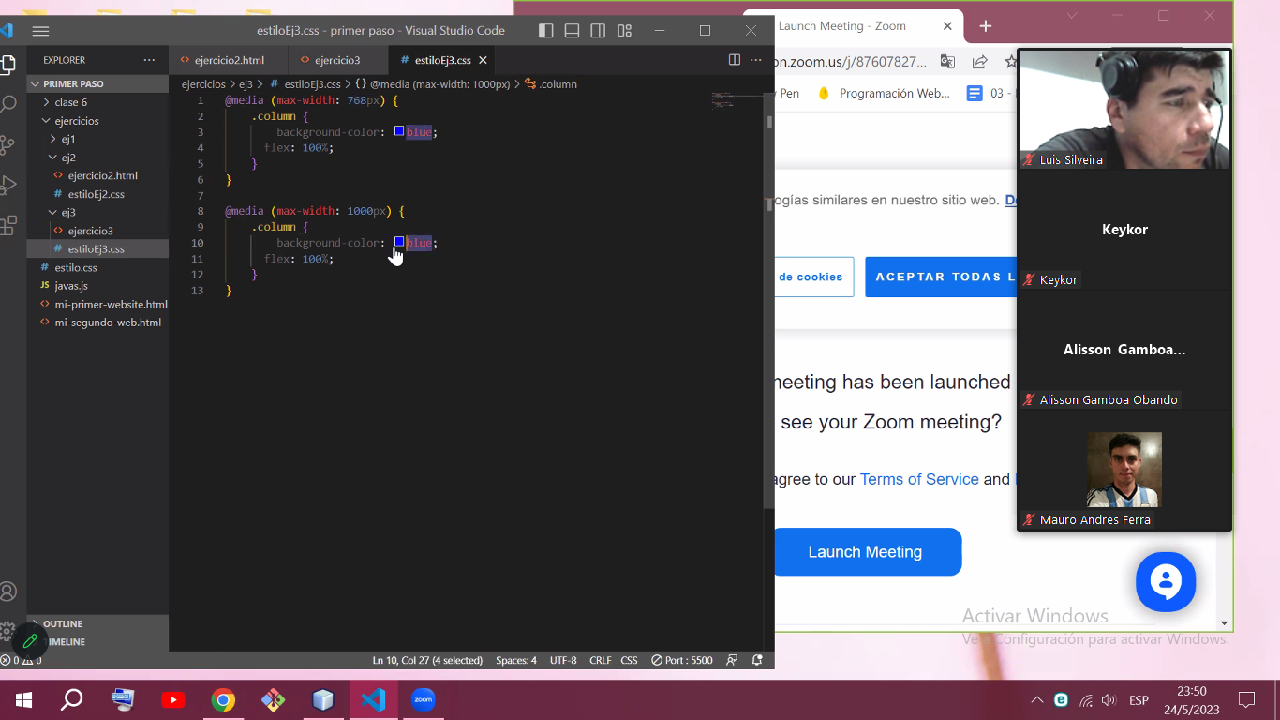

@media (max-width: 768px) { .column { background-color: blue; flex: 100%; }}@media (max-width: 1000px) { .column { background-color: red; flex: 100%; }}

